New Patient Registration Instructions
Registration • Scheduling • Patient Portal • First-Visit Paperwork
Before you begin
There are 4 steps to complete patient registration and are listed below. Your first appointment must be scheduled as a new-patient, in-person visit, and all new-patient paperwork, located on the patient portal, must be completed at least 24 hours before your appointment.

STEP 1 | REGISTER AS A NEW PATIENT
Start at the Infinite Chances website and complete the secure intake form.

1 | Go to the Infinite Chances website.  Visit infinitechances.org.

2 | Open the website menu.  Select the menu icon to view the website options.  

3 | Choose “New Patient.”  Select New Patient from the menu.  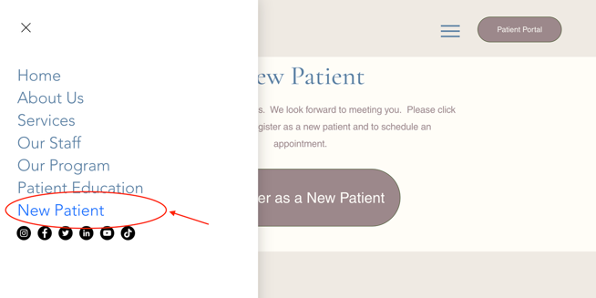

4 | Select “Register as a New Patient.”  On the New Patient page, click Register as a New Patient.  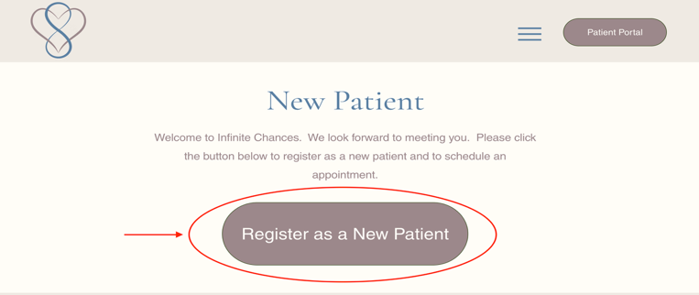

5 | Complete “Patient Details.”  Enter the requested patient information and continue through all steps of the intake form.  Important: Finish all steps before ending the session.  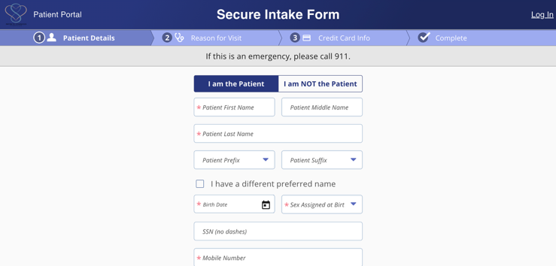

6 | Choose the reason for visit.  Under Reason for Visit, select “NEW PATIENT VISIT (90)” as shown in the intake form.  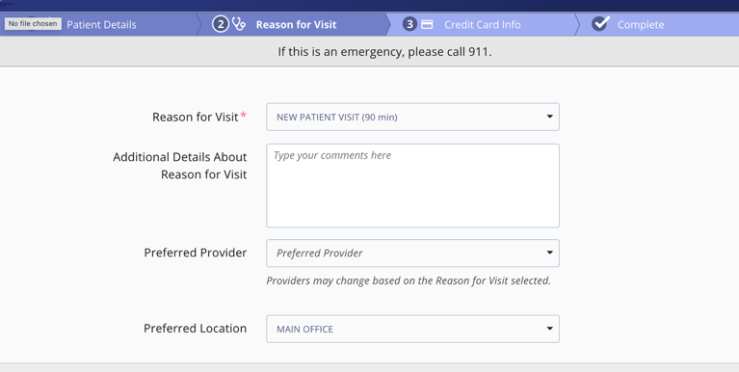

7 | Re-enter your credit card information.  Enter the requested payment card information to continue.  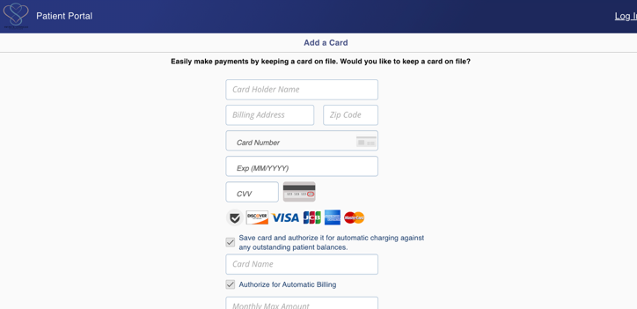

8 | Submit the form and schedule.  After you see “Form submitted successfully,” click Schedule Appointment.  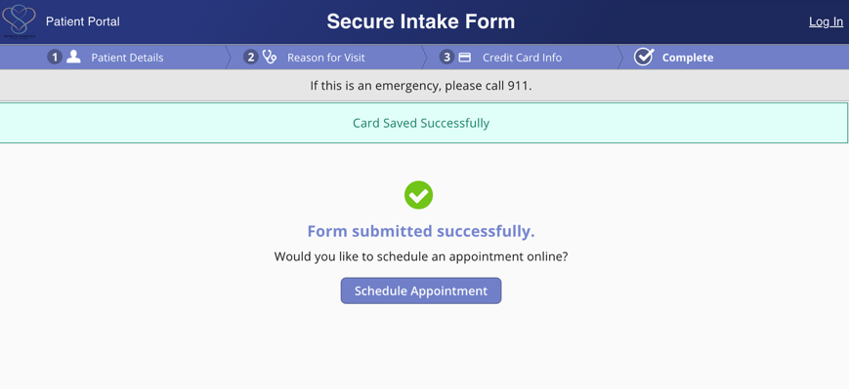

9 | STEP 2 | SCHEDULE YOUR FIRST APPOINTMENT  Choose the correct visit type, date, time, and location.  Choose:  “NEW PATIENT VISIT (60 min), if this will be your first visit with Dr. Corrine Whitaker “TRANSFER PATIENT FROM ALLIANCE (30 min/60 min in-person or telehealth) if you are transferring from Alliance Behavioral Psychiatry  Select the new-patient appointment option shown in the scheduling menu.  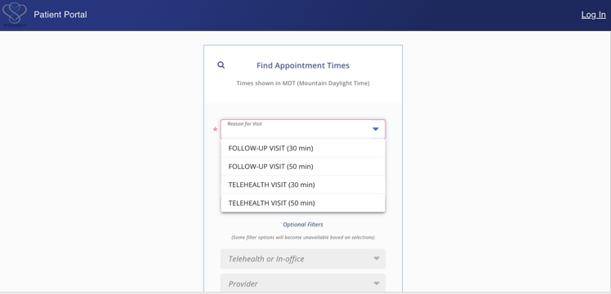

10 | Choose a day and time.  Select an available appointment time that you can attend.  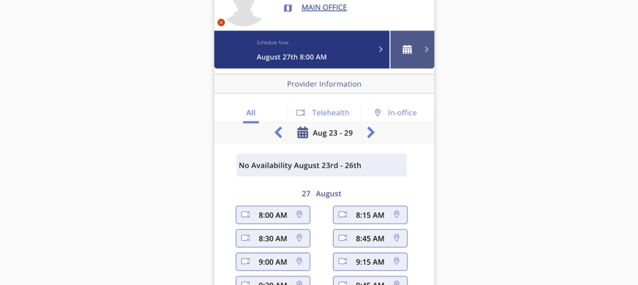

11 | Select “in-person.”  When asked to choose telehealth or in-person, select in-person for your New Patient appointment.  New Patient appointments must be in person.  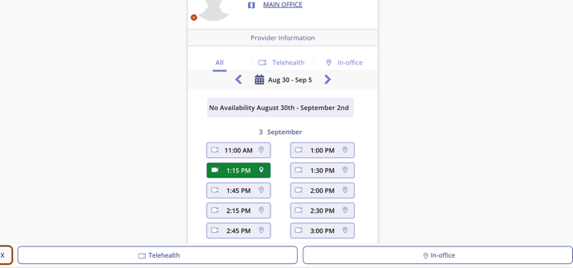

12 | Save the appointment to your calendar.  After the appointment is confirmed, add it to your calendar for your records.  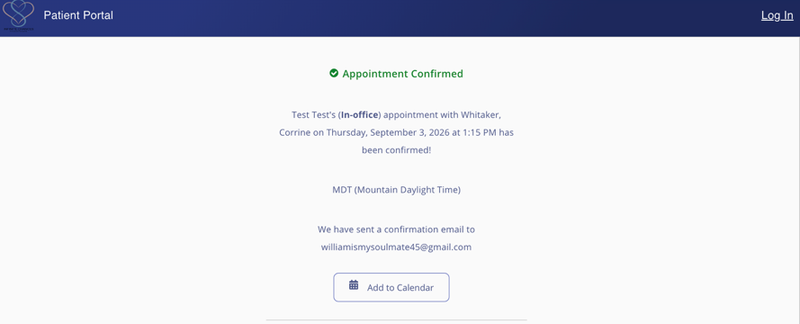

STEP 3 | CREATE YOUR PATIENT PORTAL ACCOUNT
Use the same identifying information you entered during New Patient registration.
13 | Return to infinitechances.org.  Click Patient Portal on the Infinite Chances website.  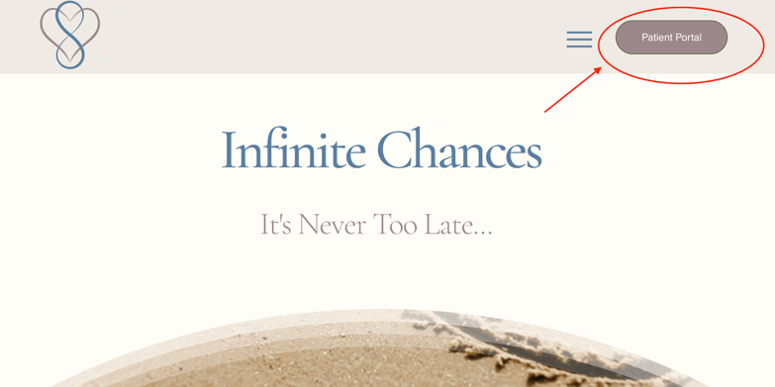

14 | Click “Registration” / “Register.”  Create your portal account using the same name and email address used for New Patient registration.  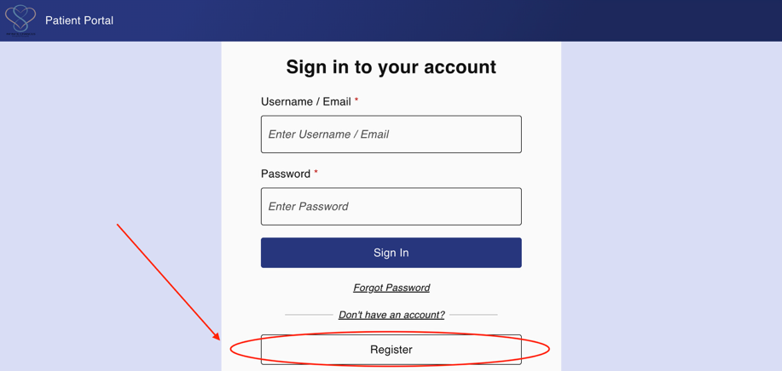

15 | Complete account registration.  Fill out the indicated fields and finish the registration process.  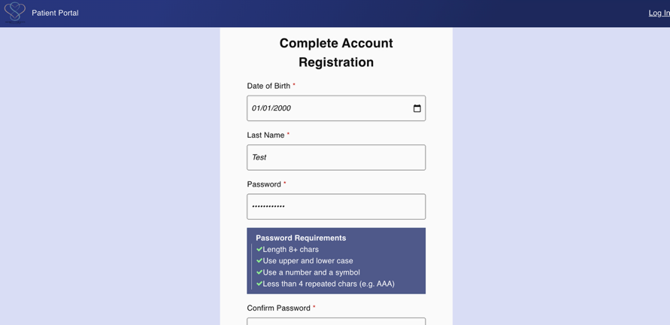

16 | Become familiar with the portal.  The portal can be used to schedule appointments, message your provider, access documents, request refills, and more.  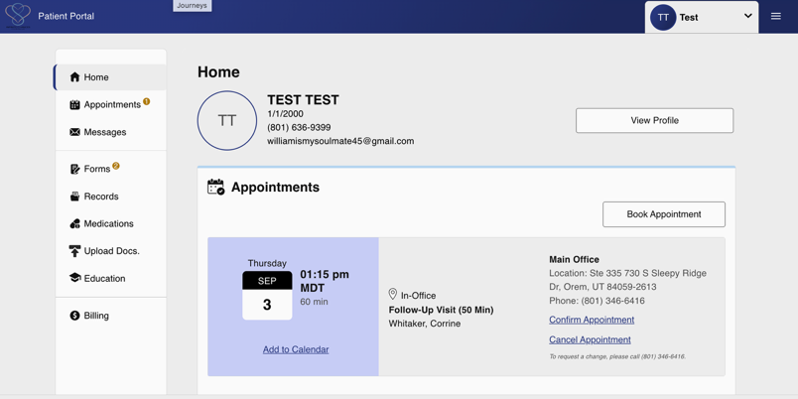

STEP 4 | COMPLETE PAPERWORK & FIND YOUR TREATMENT PLAN
These steps will help you prepare for your visit and locate documents from your provider.

17 | Complete new-patient paperwork at least 24 hours before your appointment.  In the portal sidebar, click Forms, then click Start to begin each required form. If forms are not completed before your appointment, time during the first visit will be used to complete them.  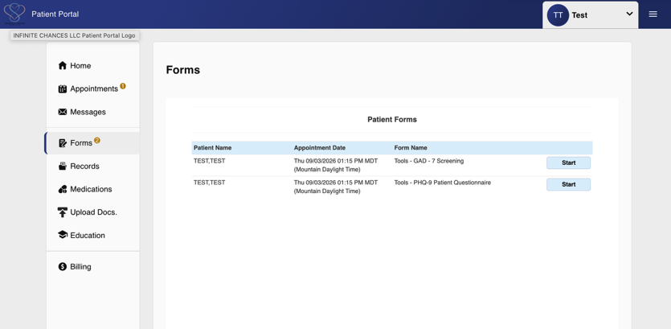

18 | Locate your updated Treatment Plan.  After each appointment, your provider will send an updated Treatment Plan that may include medication changes, therapy assignments, and other recommendations. In the portal sidebar, click Records.  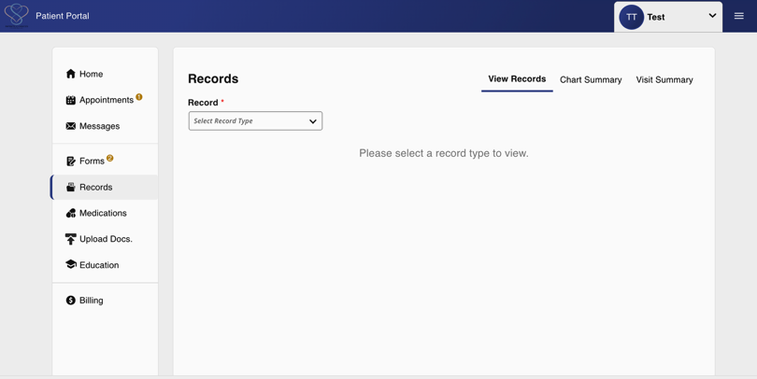

19 | Open “Docs and Images.”  From Records, use the drop-down menu and select Docs and Images to access documents sent by your provider.  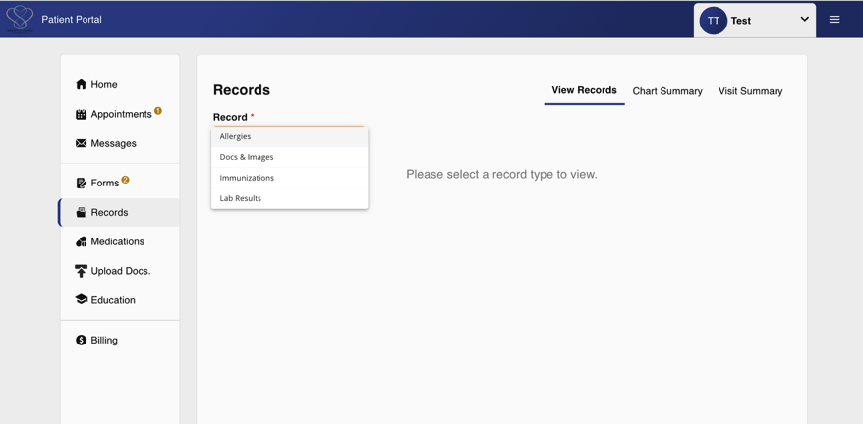

Helpful reminder
Keep your portal login information in a secure place and check the portal regularly for forms, messages, refill information, and updated treatment documents.

